
Making a difference for every child.
SP24: PSHE Policy

Owning Committee: Curriculum
Owning Governor: Curriculum
Owning School rep: Julie Robinson
Monitoring Governor: Curriculum
Date of Approval: May 2024
Date of next review: April 2027
AIM OF DOCUMENT: To provide clear guidance about the coverage and teaching of PSHE.
IN EVENT OF CONCERN/QUESTIONS: Contact the owning governor, contact details available through the school administrator.
HOW DOES THIS DOCUMENT HELP THE CHILDREN?
To support children with the personal, social, health and emotional aspects of their lives and enforce a clear and rigorous expectation on all staff and pupils to promote the fundamental British values of democracy, the rule of law, individual liberty and mutual respect and tolerance of those with different faiths and beliefs.
Revision History:
Version | Update details | Date of approval
V1 |  | June 2006
V2 | At staff meeting | September 2011
V3 | Governing Body | February 2013
V4 | Updated to reflect Jigsaw content  Governing Body/SP24 (SRE)combined | April 2016
V5 | Curriculum and Governing Body | May 2019
V5 | Create separate RSE policy and remove RSE provision from this one | April 2021
V6 | Review | May 2024
Introduction
All schools must provide a curriculum that is broadly based, balanced and meets the needs of all pupils. Under section 78 of the Education Act 2002 and the Academies Act 2010, a PSHE curriculum:
- Promotes the spiritual, moral, cultural, mental and physical development of pupils at the school and of society, and
- Prepares pupils at the school for the opportunities, responsibilities and experiences of later life.

The Government’s PSHE education review of PSHE Education impact and effective practice concludes that:
There are several common themes which run through the research cited above which provides good evidence of effective practice in PSHE education.
PSHE education should:
• take a whole-school approach, engaging pupils across the curriculum while creating an environment, through the school ethos, which fosters good relationships and well-being for pupils and teachers alike;
• include lessons which are interactive, participative and engaging; pupils’ views should be sought and older children can be involved in the development of curriculum programmes;
• have lessons with clear objectives, taught by someone who is trained and comfortable in their role;
• be inclusive of difference, including other cultures, ethnicity, disability, faith, age, sexual orientation and gender identity;
• start early and take a developmental approach; relevant to pupils’ depending on their age and maturity;
• ensure coherence, teamwork - including involvement from other agencies (where appropriate), parents, governors and members of the wider community;
• have support from the head teacher and senior management team, which reflects a respect for PSHE education and PSHE coordinators within their school;
• an element of evaluation and monitoring of both pupil and teachers’ perceptions of what leads to increased knowledge and engagement and, where possible, attempt to assess longer term outcomes.

In order to achieve these objectives, Sheet Primary School use Jigsaw materials to teach PSHE across the school. This PSHE policy is informed by existing DfE guidance on Sex and Relationships Education (Sex and Relationship Education Guidance, July 2000), preventing and tackling bullying (Preventing and tackling bullying: Advice for head teachers, staff and governing bodies, July 2013), Drug and Alcohol Education (DfE and ACPO drug advice for schools: Advice for local authorities, headteachers, school staff and governing bodies, September 2012), safeguarding (Working Together to Safeguard Children: A guide to inter-agency working to safeguard and promote the welfare of children, March 2013) and equality (Equality Act 2010: Advice for school leaders, school staff, governing bodies and local authorities, revised February 2013).
Links to these documents:
http://www.education.gov.uk/aboutdfe/statutory/g00214676/sex-and-relationships-education-guidance
https://www.gov.uk/government/publications/dfe-and-acpo-drug-advice-for-schools
http://www.education.gov.uk/aboutdfe/advice/f0076899/preventing-and-tackling-bullying
http://www.education.gov.uk/schools/guidanceandadvice?f_category=Safeguarding&page=1
http://www.education.gov.uk/aboutdfe/advice/f00215460/equality-act-2010-departmental-advice

Aim of the Jigsaw PSHE policy
To provide pupils with the knowledge, understanding, attitudes, values and skills they need in order to reach their potential as individuals and within the community.
Pupils are encouraged to take part in a wide range of activities and experiences across and beyond the curriculum, contributing fully to the life of their school and communities. In doing so they learn to recognise their own worth, work well with others and become increasingly responsible for their own learning. They reflect on their experiences and understand how they are developing personally and socially, tackling many of the spiritual, moral, social and cultural issues that are part of growing up.
They learn to understand and respect our common humanity; diversity and differences so that they can go on to form the effective, fulfilling relationships that are an essential part of life and learning.
Objectives/Pupil learning intentions:
Jigsaw PSHE will support the development of the skills, attitudes, values and behaviour, which enable pupils to:
- Have a sense of purpose
- Value self and others developing self-confidence and self esteem
- Form positive relationships
- Make and act on informed decisions regarding personal and social issues
- Communicate effectively
- Work with others showing respect to all
- Respond to challenge
- Be an active partner in their own learning
- Be active, independent and responsible citizens within school and the local community
- Explore issues related to living in a democratic society
- Become healthy and fulfilled individuals
- Be aware of how to keep themselves and others safe both inside and outside school

Use our five school values: POSITIVITY, RESPECT, EFFORT, PERSEVERANCE, KINDNESS

Jigsaw Content
Jigsaw covers all areas of PSHE for the primary phase, as the table below shows:

Term | Puzzle name | Content
Autumn 1: | Being Me in My World | Includes understanding my place in the class, school and global community as well as devising Learning Charters)
Autumn 2: | Celebrating Difference | Includes anti-bullying (cyber and homophobic bullying included) and diversity work
Spring 1: | Dreams and Goals | Includes goal-setting, aspirations, working together to design and organise fund-raising events
Spring 2: | Healthy Me | Includes drugs and alcohol education, self-esteem and confidence as well as healthy lifestyle choices
Summer 1: | Relationships | Includes understanding friendship, family and other relationships, conflict resolution and communication skills
Summer 2: | Changing Me | Includes Sex and Relationship Education in the context of looking at change (this is covered in our separate RSE policy)

As well as using this scheme of work, the school arranges for outside agencies to visit or children to visit them to enrich the children’s experiences, for example 2023/24 has seen us enjoy:
NSPCC visits, Think Safe visit Year 5/6, Fire Brigade visit Year 1/2 and 5/6, mental health whole School, careers morning whole School, Guide Dogs for the Blind and Health and Safety Week.
We offer residential visits in Key Stage 2, where there is a particular focus on developing pupils’ self-esteem and giving them opportunities to develop leadership and co-operative skills.
Personalised learning:
Teachers have the flexibility to design the curriculum to meet the needs of the children in their care or to respond to situations that may arise, (e.g. playtime issues, transitions, emotional bereavement).
We have two trained ELSA (Emotional Literacy Support Assistants) for children with specific personal, social and emotional needs. For example, nurture groups are provided for children who need additional support and guidance at particular times during their school career. We believe that this is essential to today’s children and value this resource.
MyHappyMind
MyHappyMind is a programme used here at Sheet Primary School from 2023 to promote a culture of resilience, self-esteem and individual character. Throughout, children are encouraged to explore themselves as a unique individual (personality, strengthen their relationships with friends and family, managing their own emotions and celebrate their milestones and achievements).
MyHappyMind is taught across five modules and each introduces a new set of content and habits to help children build resilience, self-esteem and confidence.
The Five Modules:
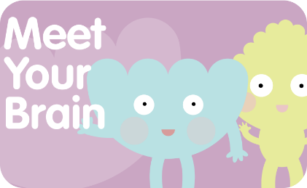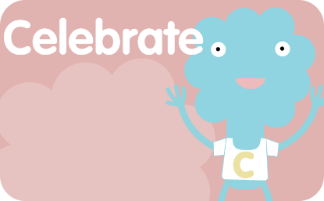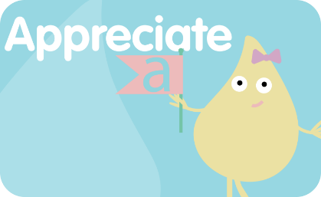
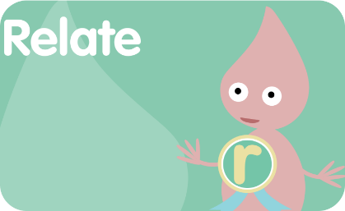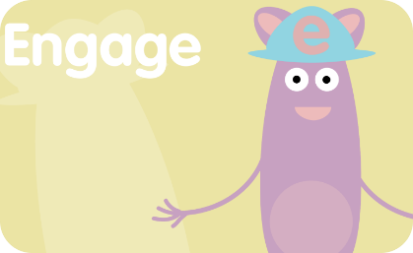
There is a free MyHappyMind Parent App where parents are able to access Happy Breathing activities and quizzes to use at anytime.

Drug and Alcohol Education
Definition of ‘Drugs’:
This policy uses the definition that a drug is: ‘A substance people take to change the way they feel, think or behave’ (United Nations Office on Drugs and Crime). The term ‘Drugs’ includes
- All illegal drugs
- All legal drugs including alcohol, tobacco and volatile substances which can be inhaled
- All over-the-counter and prescription medicines

Effective Drug and Alcohol Education can make a significant contribution to the development of the personal skills needed by pupils as they grow up. It also enables young people to make responsible and informed decisions about their health and well-being.

Moral and Values Framework

The Drug and Alcohol Education programme at our school reflects the school ethos and demonstrates and encourages the following values.

For example:
- Respect for self
- Respect for others
- Responsibility for their own actions
- Responsibility for their family, friends, schools and wider community

Jigsaw Drug and Alcohol Education Content
The grid below shows specific Drug and Alcohol Education learning intentions for each year group in the ‘Healthy Me’ Puzzle.
Year Group | Piece Number and Name | Learning Intentions  ‘Pupils will be able to…’
2 | Piece 3  Medicine Safety | understand how medicines work in my body and how important it is to use them safely  feel positive about caring for my body and keeping it healthy
3 | Piece 3  What Do I Know About Drugs? | tell you my knowledge and attitude towards drugs  identify how I feel towards drugs
4 | Piece 3  Smoking | understand the facts about smoking and its effects on health, and also some of the reasons some people start to smoke  can relate to feelings of shame and guilt and know how to act assertively to resist pressure from myself and others
4 | Piece 4  Alcohol | understand the facts about alcohol and its effects on health, particularly the liver, and also some of the reasons some people drink alcohol  can relate to feelings of shame and guilt and know how to act assertively to resist pressure from myself and others
5 | Piece 1  Smoking | know the health risks of smoking and can tell you how tobacco affects the lungs, liver and heart  make an informed decision about whether or not I choose to smoke and know how to resist pressure
5 | Piece 2  Alcohol | know some of the risks with misusing alcohol, including anti-social behaviour, and how it affects the liver and heart  make an informed decision about whether or not I choose to drink alcohol and know how to resist pressure
6 | Piece 2  Drugs | know about different types of drugs and their uses and their effects on the body particularly the liver and heart  be motivated to find ways to be happy and cope with life’s situations without using drugs
6 | Piece 3  Alcohol | evaluate when alcohol is being used responsibly, anti-socially or being misused  tell you how I feel about using alcohol when I am older and my reasons for this

How is Jigsaw PSHE organised in school?
Jigsaw brings together PSHE Education, emotional literacy, social skills and spiritual development in a comprehensive scheme of learning. Teaching strategies are varied and are mindful of preferred learning styles and the need for differentiation. Jigsaw is designed as a whole school approach, with all year groups working on the same theme (Puzzle) at the same time. This enables each Puzzle to start with an introductory assembly, generating a whole school focus for adults and children alike. As a small school, we make a decision on which year group Jigsaw will be followed so that material is varied and appropriate across the two year cycle.
There are six Puzzles in Jigsaw that are designed to progress in sequence from September to July. Each Puzzle has six Pieces (lessons) which work towards an ‘end product’, for example, The School Learning Charter or The Garden of Dreams and Goals.
Each Piece has two Learning Intentions: one is based on specific PSHE learning (covering the non-statutory national framework for PSHE Education but enhanced to address children’s needs today); and one is based on emotional literacy and social skills (covering the SEAL learning intentions but also enhanced). The enhancements mean that Jigsaw is relevant to children living in today’s world as it helps them understand and be equipped to cope with issues like body image, cyber and homophobic bullying, and internet safety.
Every Piece (lesson) contributes to at least one of these aspects of children’s development. This is mapped on each Piece and balanced across each year group.

Differentiation/SEN
Jigsaw is written as a universal core curriculum provision for all children. Inclusivity is part of its philosophy. Each Piece is tailored to meet the needs of the children in their classes. To support this differentiation, many Jigsaw Pieces use creative learning activities that allow children to choose the media with which they work and give them scope to work to their full potential. To further help teachers differentiate for children in their classes with special educational needs, each Puzzle includes a P-level grid with suggested activities for children working at each of those levels.
Safeguarding
Teachers need to be aware that sometimes disclosures may be made during these sessions; in which case, safeguarding procedures must be followed immediately. Sometimes it is clear that certain children may need time to talk one-to-one after the circle closes. We make sure that time is allowed for this to happen. If disclosures occur, the school’s Safeguarding Policy is followed.
The Attainment Descriptors
The Jigsaw philosophy is that children are praised and their achievements celebrated in every Piece. It demands a positive relationship between the teacher and the children which, in itself, values and celebrates each individual. Appropriate time is allocated for this process.
The Learning Environment
Establishing a safe, open and positive learning environment based on trusting relationships between all members of the class, adults and children alike, is vital. To enable this, ‘ground rules’ are agreed and owned at the beginning of the year and are reinforced in every Piece – by using The Jigsaw Charter. This is referred to throughout the lesson and beyond.
The Jigsaw Charter
- We take turns to speak
- We use kind and positive words
- We listen to each other
- We have the right to pass
- We only use names when giving compliments or when being positive
- We respect each other’s privacy (confidentiality)

Teaching Sensitive and Controversial Issues
Sensitive and controversial issues are certain to arise in learning from real-life experience. Teachers are prepared to handle personal issues arising from the work, to deal sensitively with, and to follow up appropriately, disclosures made in a group or individual setting. Issues that we address that are likely to be sensitive and controversial because they have a political, social or personal impact or deal with values and beliefs include: family lifestyles and values, physical and medical issues, financial issues, bullying and bereavement.
Teachers take all reasonable, practical steps to ensure that, where political or controversial issues are brought to pupils’ attention, they are offered a balanced presentation of opposing views. Teachers will adopt strategies that seek to avoid bias on their part and will teach pupils how to recognise bias and evaluate evidence. Teachers will seek to establish a classroom climate in which all pupils are free from any fear of expressing reasonable points of view that contradict those held either by their class teachers or their peers.

Answering Difficult Questions and Sensitive Issues
Staff members are aware that views around Drug and Alcohol Education-related issues are varied. However, while personal views are respected, all Drug and Alcohol Education issues are taught without bias using Jigsaw. Topics are presented using a variety of views and beliefs so that pupils are able to form their own, informed opinions but also respect that others have the right to a different opinion.
Both formal and informal Drug and Alcohol Education arising from pupils’ questions are answered according to the age and maturity of the pupil(s) concerned. Questions do not have to be answered directly, and can be addressed individually later. The school believes that individual teachers must use their skill and discretion in this area and refer to the Designated Safeguarding Lead/Deputy if they are concerned.
Our school believes that Drug and Alcohol Education should meet the needs of all pupils, answer appropriate questions and offer support.

Involving parents and carers
The school believes that it is important to have the support of parents, carers and the wider community for the Jigsaw PSHE programme. Parents and carers are given the opportunity to find out about and discuss the Jigsaw PSHE programme through:
- Parent/carer Jigsaw awareness session
- Parents’/carers’ evenings
- Involvement in policy development
- Involvement in curriculum development
- Information leaflets/displays

Pupil Consultation:
- It is useful for pupils to be consulted on their own personal, social and citizenship development. This is done through discussion in the lessons and when monitoring at the end of each term.

Links to other policies and curriculum areas
We recognise the clear link between Jigsaw PSHE and the following policies and staff are aware of the need to refer to these policies when appropriate.
- RSE Policy
- Curriculum Policy
- Teaching and Learning Policy
- Equal Opportunities Policy
- Safeguarding Policy

Training and support for staff
All staff benefit from Jigsaw PSHE training in order to enhance their PSHE delivery skills. Opportunities are provided for staff to identify individual training needs on a yearly basis and relevant support is provided.
In addition to this, support for teaching and understanding PSHE issues is incorporated in our staff INSET programme, drawing on staff expertise and/or a range of external agencies.
Dissemination
This policy is available on our school website where it can be accessed by the community. Training is regularly delivered to staff on the policy content. Copies are available from the school office on request from parents/carers.
Confidentiality and Child Protection Issues
As a general rule a child’s confidentiality is maintained by the teacher or member of staff concerned. If this person believes that the child is at risk or in danger, she/he talks to the Designated Safeguarding Lead/Deputy who takes action as laid down in the Safeguarding Policy. All staff members are familiar with the policy and know the identity of the member of staff with responsibility for Child Protection issues. The child concerned will be informed that confidentiality is being breached and reasons why. The child will be supported by the teacher throughout the process.
Policy Review
This policy is reviewed every 3 years.
 | Signed Headteacher | Signed Governor | Signed Chair of Governors
Date of review:

