Personal, Social & Emotional Development –
Physical Development - Understanding the World - PSHE overview
Active Learning - Motivation |  |  | Creating & Thinking Critically - Thinking
- Being involved & concentrating  - Keep on trying  - Enjoying achieving what they set out to do |  |  | - Having their own ideas (creative thinking)  - Making links (building theories)  - Working with ideas (critical thinking
ELG
Self-regulation
- Show an understanding of their feelings & begin to regulate their behaviour accordingly
- Set & work towards simple goals, being able to wait for what they want & control their immediate impulses when appropriate
- Give focussed attention to what the teacher says, responding appropriately even when engaged in activity, & show an ability to follow instructions involving several ideas or actions
Managing Self
- Be confident to try new activities & show independence, resilience & perseverance in the face of challenge
- Explain the reasons for rules, know right from wrong & try to behave accordingly
- Manage own basic hygiene & personal needs, including dressing, going to the toilet & understanding the importance of healthy food choices
Building Relationships
- Work & play cooperatively & take turns with others
- Form positive attachments to adults & friendships with peers
- Show sensitivity to their own & other’s needs
 | Health & well-being | Relationships |  | Living in the wider world
Reception | • Know & talk about the different factors that support their overall health & well-being: regular physical activity, healthy eating, tooth brushing, sensible amounts of screen time, having a good sleep routine, being a safe pedestrian  • Can describe their competencies, what they can do well & are getting better at describing themselves in positive but realistic terms  • Is proactive in seeking adult support and able to articulate their wants and needs | • Develops particular friendships with other children, which help them to understand different points of view and to challenge their own and others’ thinking  • Is increasingly socially skilled and will take steps to resolve conflicts with other children by negotiating and finding a compromise; sometimes by themselves, sometimes with support  • Is more able to manage their feelings and tolerate situations in which their wishes cannot be met  • Knows that other children do not always enjoy the same things, and is sensitive to this |  | • Further develop the skills they need to manage the school day successfully: lining up & queuing, mealtimes, personal hygiene  • Recognise that they belong to different communities & social groups & communicates freely about own home & community  • Attempts to repair a relationship or situation where they have caused upset and understands how their actions impact other people

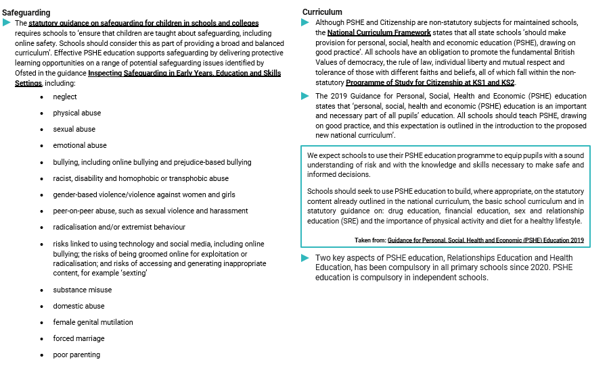
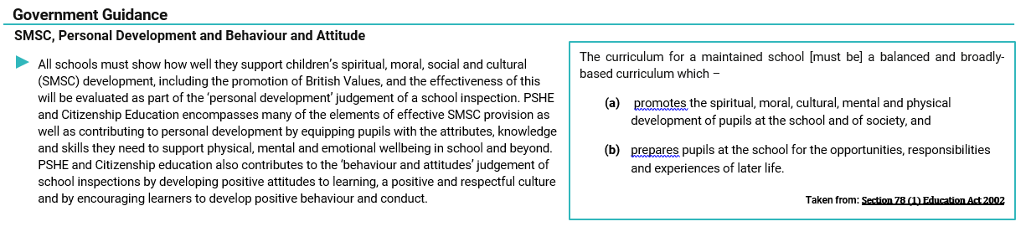

At Sheet Primary School we teach PSHE through a scheme of learning called Jigsaw. Jigsaw is a mindful and child-centred approach to PSHE. It is an original and comprehensive scheme of learning which encompasses personal, social, health education with emphasis on emotional literacy, mental health, British Values and SMSC especially spiritual development. Jigsaw aims to help children know who they are and how they relate to other children in this ever changing world.

Order of Study
Here is an order of study using Jigsaw scheme of work.
 | Autumn 1 | Autumn 2 | Spring 1 | Spring 2 | Summer 1 | Summer 2
Reception | Being Me in My World | Celebrating Difference | Dreams and Goals | Healthy Me | Relationships | Changing Me
Year 1/2 | Being Me in My World | Celebrating Difference | Dreams and Goals | Healthy Me | Relationships | Changing Me
Year 3/4 | Being Me in My World | Celebrating Difference | Dreams and Goals | Healthy Me | Relationships | Changing Me
Year 5/6 | Being Me in My World | Celebrating Difference | Dreams and Goals | Healthy Me | Relationships | Changing Me

Yearly overviews are available as on separate documents.

